LAB 2
Task 1
Quick Sorting Algorithm
#include <iostream>
#include <vector>
using namespace std;

int partition(vector<int>& arr,int low , int high,int& count,int& loop){
int pivot = arr[high];
int i=low-1;

for (int j=low ; j <= high-1;j++){
if(arr[j]<pivot){
i++;
swap(arr[i],arr[j]);
count ++;
}
loop++;
}

swap(arr[i+1],arr[high]);
return i+1;
}

void quicksort(vector<int>& arr,int low , int high,int& count,int& loop){
if (low<high){
int pi = partition(arr,low,high,count,loop);
quicksort(arr,low,pi-1,count,loop);
quicksort(arr,pi+1,high,count,loop);
}
}

int main (){
vector<int> arr = {10, 7, 8, 9, 1, 5, 2, 6, 3, 4};
int n = arr.size();
int count = 0;
int loop = 0;
quicksort(arr,0,n-1,count,loop);
cout<<"Number of Swaps: "<<count<<endl;
cout<<"Number of loops: "<<loop<<endl;
cout<<"Sorted array: ";
for (int i=0;i<n;i++){
cout<<arr[i]<<" ";
}
}
 | LOOPS | SWAPS
BEST | 45 | 45
WORSE | 45 | 20
AVG | 22 | 14
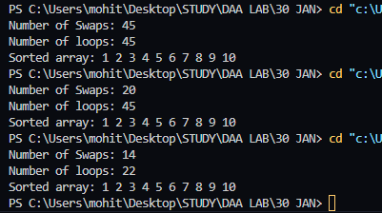

PIVOT ELEMENT AS FIRST
#include <iostream>
#include <vector>
using namespace std;

int partition(vector<int>& arr, int low, int high, int& count, int& loop) {
int pivot = arr[low];
int i = low + 1;

for (int j = low + 1; j <= high; j++) {
if (arr[j] < pivot) {
swap(arr[i], arr[j]);
i++;
count++;
}
loop++;
}
cout<<pivot<<endl;
swap(arr[low], arr[i - 1]);
return i - 1;
}

void quicksort(vector<int>& arr, int low, int high, int& count, int& loop) {
if (low < high) {
int pi = partition(arr, low, high, count, loop);
quicksort(arr, low, pi - 1, count, loop);
quicksort(arr, pi + 1, high, count, loop);
}
}

int main() {
vector<int> arr = {10,40,80,70,50};
int n = arr.size();
int count = 0;
int loop = 0;
quicksort(arr, 0, n - 1, count, loop);

cout << "Number of Swaps: " << count << endl;
cout << "Number of loops: " << loop << endl;
cout << "Sorted array: ";
for (int i = 0; i < n; i++) {
cout << arr[i] << " ";
}
}

 | LOOPS | SWAPS
BEST | 45 | 45
WORSE | 45 | 20
AVG | 22 | 14
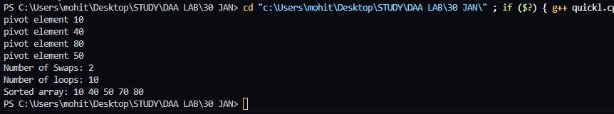

TASK 2
Decimal to Binary (Iterative)
#include <iostream>
using namespace std;

int main() {
int decimal, binary = 0, place = 1;

cout << "Enter a decimal number: ";
cin >> decimal;

int originalDecimal = decimal;

while (decimal > 0) {
int remainder = decimal % 2;
binary += remainder * place;
place *= 10;
decimal /= 2;
}

cout << "The binary of " << originalDecimal << " is: " << binary << endl;

return 0;
}

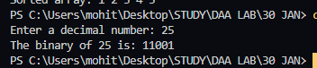
Decimal to Binary Recursive
#include <iostream>
using namespace std;

void decimalToBinary(int decimal) {
if (decimal == 0) {
return;
}
decimalToBinary(decimal / 2);
cout << decimal % 2;
}

int main() {
int decimal;
cout << "Enter a decimal number: ";
cin >> decimal;

if (decimal == 0) {
cout << "The binary of 0 is: 0" << endl;
} else {
cout << "The binary of " << decimal << " is: ";
decimalToBinary(decimal);
cout << endl;
}

return 0;
}

LEETCODE PROBLEM
Given an m x n 2D binary grid grid which represents a map of '1's (land) and '0's (water), return the number of islands.
An island is surrounded by water and is formed by connecting adjacent lands horizontally or vertically. You may assume all four edges of the grid are all surrounded by water.
class Solution {
public:
int numIslands(vector<vector<char>>& grid) {
constexpr int dirs[4][2] = {{0, 1}, {1, 0}, {0, -1}, {-1, 0}};
const int m = grid.size();
const int n = grid[0].size();
int ans = 0;

auto bfs = [&](int r, int c) {
queue<pair<int, int>> q{{{r, c}}};
grid[r][c] = '2'; // Mark '2' as visited.
while (!q.empty()) {
const auto [i, j] = q.front();
q.pop();
for (const auto& [dx, dy] : dirs) {
const int x = i + dx;
const int y = j + dy;
if (x < 0 || x == m || y < 0 || y == n)
continue;
if (grid[x][y] != '1')
continue;
q.emplace(x, y);
grid[x][y] = '2'; // Mark '2' as visited.
}
}
};

for (int i = 0; i < m; ++i)
for (int j = 0; j < n; ++j)
if (grid[i][j] == '1') {
bfs(i, j);
++ans;
}

return ans;
}
};

